Created in the cloud with Aspose.Words for Cloud. http://www.aspose.com/cloud/word-api.aspx

WHAT’S GOING ON: Wofford College to Host November Presidential Debate
Published Date : October 26, 2011
Author : admin
CBS News and National Journal will present the first Republican Presidential Primary debate on broadcast television on Saturday, November 12. David Rhodes, President, CBS News, and Ron Fournier, editor-in-chief of National Journal, announced the debate, which will focus primarily on national security and will be held in conjunction with the South Carolina State Republican Party. Scott Pelley, anchor and managing editor of the CBS EVENING NEWS WITH SCOTT PELLEY, and Major Garrett, congressional correspondent for National Journal, will moderate the debate, which will be hosted by Wofford College in Spartanburg, South Carolina.
The 90-minute debate will begin at 8:00 PM ET/5:00 PM PT. The first hour will be broadcast live (8:00-9:00 PM, ET/5:00-6:00 PM, PT) on the CBS Television Network. Additional portions will be broadcast on FACE THE NATION, CBSNews.com, NationalJournal.com and will be available to CBS affiliate television and radio stations.
“The first debate of the campaign on broadcast television will be on CBS,” said Rhodes. “Scott Pelley and all of us at CBS News look forward to a spirited discussion of the issues with all of the Republican candidates in Spartanburg next month.”
“This debate will examine the critical questions of America’s role in the world, now and in the future,” said Fournier. “National Journal is proud to build on our 2012 election partnership with CBS News to give voters a thorough understanding of how each of the Republican candidates would take on these issues.”
“The South Carolina Republican Party is excited to be a partner on the first nationally televised, broadcast network debate of the Presidential Primary season,” said Chad Connelly, Chairman of the South Carolina Republican Party. “Presidential candidates and Republican activists across our nation know South Carolina’s historic tradition of successfully choosing the Republican nominee, a tradition uninterrupted for over thirty years. We look forward to the November 12 debate on Wofford College’s beautiful campus and continuing to demonstrate that in South Carolina, ‘We Pick Presidents.’”
“In politics, everyone aims to be a winner, so, given our tradition of athletic success, Wofford College is an encouraging location for a presidential candidates’ debate. And given our national leadership among foreign study programs, we’re a logical place in which to hold discussions on the subject of national security,” said Dr. Benjamin B. Dunlap, President of Wofford College. “Most significantly, it’s our institutional dedication to ‘the unfettered pursuit of knowledge’ that makes us such an appropriate host as we welcome the candidates to our beautiful and historic campus.”
During the Republican debates that have been held to date, the candidates have sought to define themselves against each other and President Barack Obama. The CBS News/National Journal debate will reveal the candidates’ views on wide-ranging foreign affairs topics, such as the wars in Afghanistan and Iraq, the changes throughout the Middle East, Africa, and Asia, and the global war on terror.
10/27 UPDATE: SC GOP Chair Chad Connelly told us this morning that since announcing the November 12 presidential debate yesterday, the state party has received over 900 individual ticket requests in addition to more than 2700 tickets ordered. “We will announce a halt in ticket requests today and are only going to add to the pre- and post-debate reception numbers at this point,” Connelly said. The information for the Wofford debate and the form to request tickets can be found at www.scgop.com/debate until ticket requests are no longer being processed. Only “Silver Elephant” members will be guaranteed at that point.

Tweet

Comments

WHAT’S GOING ON: Andie MacDowell is Moving
Published Date : October 25, 2011
Author : admin

Gaffney native, actress, and L’Oreal spokeswoman Andie MacDowell is moving, and if you want her house, it can be yours for a scant $4.5 million.
The custom-built 4 story, 6 bedroom, 7.5 bath stone Tudor in Asheville, NC’s Biltmore Forest boasts 10,872 heated square feet, 1977 square feet of terraces, porches and balconies, and 6 fireplaces. Sitting on 2 acres, McDowell’s estate overlooks the 7th fairway of Biltmore Forest Country Club.
Maybe she misses the Peachoid.

PHOTO CREDIT: Preferred Properties of Asheville





You have a voice. Use it.

































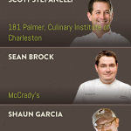





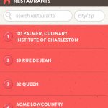



Tweet

Comments

CRESCENT Things: James Beard Award Winner Ted Lee (Part 4)
Published Date : October 24, 2011
Author : admin
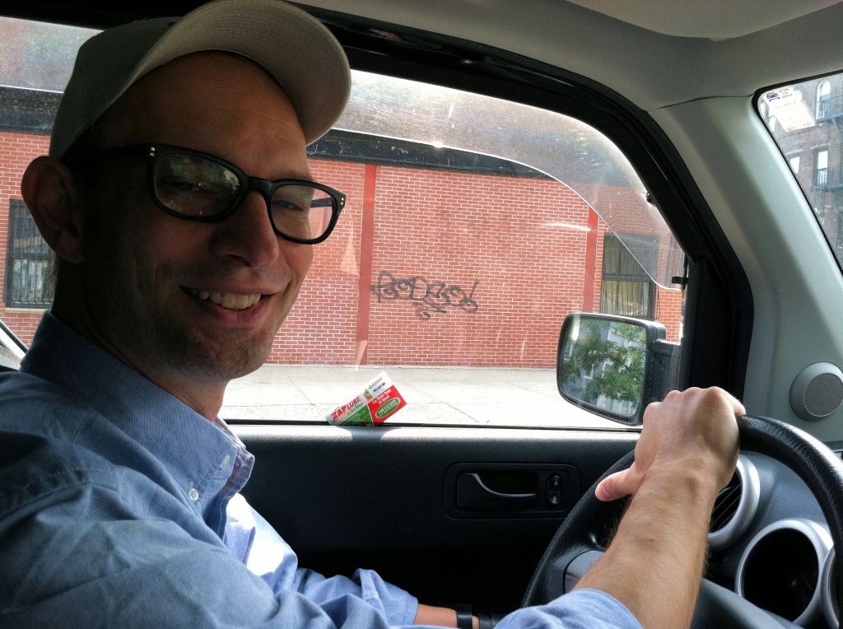
WHY CAN’T GREENVILLE GET CHARLESTON OYSTERS?
We just keep ‘em all. I keep thinking, Matt and I are experimenting with FedEx because We’ll do oyster roasts up here and you can’t find clusters, they don’t sell them out at the Hunts Point Fish Market. We’ve done experiments where the guy who does our packing for us in Charleston, he packed up a bushel of oysters in dry ice and sent it 2-day FedEx. It’s really expensive and it worked really well. There is something weird, though, about getting that cluster oyster and attacking it in a New York apartment. Something is lost in translation.
HAVING YOUR OWN OYSTER KNIFE IS IMPORTANT
It’s another one of those “life things.” When you’re growing up, and I always ask this, why do you keep the oyster knife in the glove compartment? Fast forward 20 years. You’re hosting an oyster roast. There’re 12 people coming over, and you have 4 knives and you say, “Damn, I hope one of my guests brings their own oyster knife.” You keep your own oyster knife in your glove compartment. It’s just what we do.
EDUCATING THE NEW YORK TIMES ON SOUTHERN FOOD CULTURE
There’s a great tradition of Southern food writers for the New York Times. Craig Claiborne, who is from Mississippi, wrote for them for 30 years or so. He left in the 70s, and they didn’t have anyone filling in. They didn’t have anyone covering the “Man in the South” or the “Woman in the South.” Now, everyone is writing about the South. It’s great because I do feel like there are so many stories to be told and there will always be. Whether you’re going back to heirloom varieties of stuff or whether you’re writing about the newest, greatest mixologist in Charleston.
AND SPEAKING OF CHARLESTON, THERE’S SEAN BROCK.
He’s right between our office and where we live. We’re psyched about the arrival of Husk. It’s really good. A great brunch. It’s a great bar, too, a great bar scene. It’s just a really, something that Charleston didn’t have, I don’t think.
He has this sort of two directions that he goes into. Like he goes deep into the past to find a way forward. It confused a lot of people in town, but it’s just part of … he’s very much into experimentation. He’s enthusiastic. He’s into history. I think Charleston and South Carolina in general worked their magic on him. Basically, he’s from Virginia and he grew up in a rural Virginia farm-like community, but it’s different from the Lowcountry. I think if you talk to him, I don’t know, I haven’t interviewed him enough to know, he was expecting he was going to bring all this new molecular gastronomy to town. He did. He did it brilliantly. I’m not sure he even realized how much South Carolina re-focused him — you know, broadened his horizon.
FOOD AND WINE FESTIVALS ARE MORE POPULAR THAN EVER
I mean the whole festival culture has blown up. It’s fun. It’s where a lot of the cross-pollination happens. It’s where chefs discover other ingredients. I’ve seen it happen. I’ve seen a lot of chefs, when they come from New York or Chicago to the Charleston Food and Wine Festival, just get blown away. They’re just seeing a tiny part of it, you know.
The winter weather in New York or DC or wherever they’re coming from stinks. They come down for this weekend, and they’re like, “My God. I’m moving here. I’m getting a place here.” They all say that. “I’m looking at a place here.” What I try to do is say, “You’ve just discovered one micro-region. Go to the Upstate. Go to the mountains.” I try to explain the connections from mountains to the sea.
BOILED PEANUTS TAKING OVER THE BIG APPLE IN 2000?
We started out thinking we were going to sell them wholesale. Like we were going to bring boiled peanuts to New York just like any other food. We’re eating Anson Mills grits right here (at Egg during the interview). Ten years ago, unimaginable, completely unimaginable that we would be eating South Carolina products at the restaurant in Williamsburg.
So we were going to wholesale them to bars and restaurants as a snack, not just to Southern places. We thought they were going to take off everywhere because we were so in our South Carolina mentality that we couldn’t genuinely understand there was an education curve. We’d just show up with boiled peanuts at a restaurant, walk in the door and say, “We’ve got this product, a classic regional South Carolina Product. I see you’ve got a bar. They’re salty, really delicious. You just crack open the shell.” People were just like, “Are you kidding me? Where is your Candid Camera? Because you are taking that turd-looking thing and getting the hell out of my restaurant.” It was an interesting education because part of it was we started with the Southern restaurants because we thought that was where it was going to happen.
The Southern restaurants were all run by guys from Long Island who had taken a trip to Daytona and seen a barbecue place and they came back to New York and, all about themes like “Chat n’ Chew.” It was hokey. You’d walk in and there would be a wagon wheel. That’s western. You know, like, wagon wheels, things like bullet-holed Coca-Cola signs. We deal with that now. TV producers come to Charleston and ask, “Do you know if there is a Coca-Cola sign with some bullet holes?” Like, why are you still using that that? That was a joke in the Depression. We’re beyond that.
THE LEE BROTHERS BEGIN THEIR RISE
So there was that and there was one restaurateur named Alexander Smalls who opened a beautiful place so far ahead of its time. If he opened it now, it would kill because people who are not from the South, who live here, are so much more educated now about Southern food. At that time, it was torqued up, you know, simple but an upscale restaurant serving Southern food. It was backed by… Alexander was the chef-owner. Wynton Marsalis was one of the investors, the jazz artist. The writer Toni Morrison was one of his investors. It was a beautiful place in the Flatiron District. It was amazing. He was like “Yes, I’m from Orangeburg. Come on in. He also had been an opera singer. We’d seen him perform before at the Spoleto Festival although we’d only realized that after. Because I’d seen Porgy and Bess during Spoleto in 1982, and he was one of the characters in it.
It’s so funny. He runs a music school now. But he said, “I’ll put them on my bar, I’ll sell them, I’ll educate people,” and he was the only person who let us in the front door. He carried them on the bar for about a month and he said, “You know what guys, I love boiled peanuts. I have talked myself hoarse trying to sell these boiled peanuts, but they’re just not moving.” That’s when we realized the job of educating people is not something we can do singlehandedly, so let’s sell to people who already know what they are. We had enough Southern friends around who thought it was a good idea. They said they’d buy them. I don’t know where to get raw peanuts around here myself but at a party, so why don’t you. So that’s when we started the catalog.
After a great Southern breakfast, the two boys from South Carolina left the Charleston chef’s restaurant in Brooklyn’s Williamsburg. We hopped in Ted’s Honda, and he dropped me off to catch a cab back in to Manhattan so I could get to the baseball game on time. The story won’t end here. We’ll be with both Ted and Matt soon — talking about how they got started and about their new book “Lee Brothers Charleston Kitchen.”
Read Part 1 HERE, Part 2 HERE, and Part 3 HERE.
Tweet

Comments

CRESCENT Places: Grits & Groceries (Part 4)
Published Date : October 24, 2011
Author : admin
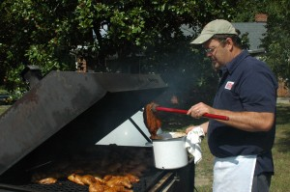
YOUR KIDS DON’T HAVE TO EAT JUNK
HEIDI: We have this big argument with people who come in and want chicken fingers. Well, not really an argument. I say “Chickens don’t really have fingers. But we have our really nice natural chicken, would you like for me to fry a chicken breast for you?” “No, my kids won’t eat anything but chicken fingers.” Well, they will if they get hungry enough, they will.
Most kids will, it’s the parents who think the kids won’t. We have kids, my son is 6. We have kids who come over here. Their parent’s say “They won’t eat that.” I put it on the table and they eat it. Joe’s nephew, his sister said “He won’t eat any of that.” He ate everything that was on the table. She said she’d never seen him eat any of these foods.
HOW SC STACKS UP TO OTHER STATES IN CULINARY STYLE
HEIDI: I think South Carolina is like Louisiana. There are 2 different components. There’s Charleston / Hilton Head, and there’s the rest of the state. In Louisiana, there’s New Orleans and there’s the rest of the state. So it’s a little different. It’s easy to be good where you have a lot of customers, in the lower part of the state, the coastline, same with New Orleans. It’s a lot harder to be good further away where we’re relying on a smaller base of customers and sharing a lot more. It’s just an individual basis. We have as good a chefs, maybe not as many because we don’t have as many customers for them. What do you think?
JOE: That makes sense. There are pockets of really great… There are really great barbecue chefs here. Barbecue is obviously huge part of South Carolina, huge part of the tradition. There are a lot of good barbecue restaurants here, but there are also a lot of bad barbecue restaurants here, too. But you know, you have to sort of search ‘em out.
HEIDI: Then be faithful to them and support them. What we’ve seen here is that Anderson County loves a new restaurant…for about 3 weeks. Then they go to the next new restaurant. When you find one, you have to support it. That’s the big difference. And then, in big cities, especially pedestrian cities, once you get your customers, they stay with you. They’re on a walking basis. It’s a little harder here where we have to rely on people to drive from Greenville or Anderson.
JOE: In Greenville, you have a lot of great chefs because it is kind of a metropolitan area and you have people to support it. And I’m sure Columbia has some really good restaurants. It matters if you have the fan base and the people to support you. Here, we have to work a little harder to get those people here. We have to be a destination location. Our local clientele has supported us really well for a long time, but we’re also counting on people traveling. It’s an interesting place to come.
FUN WITH VEGETARIANS
HEIDI: We had a couple come through from DC who were thinking about locating to South Carolina so they traveled the Heritage Corridor looking at everything. They came in and they were real excited because they were vegetarians and we had a vegetable plate that day. And then I said “How committed to vegetarian are you?” And they said “What do you mean?” I said “We kind of think of it as a Don’t Ask, Don’t Tell” so I had collard greens, pinto beans, fries, squash casserole and cornbread that day so the only thing that didn’t have ham hock would have been the squash casserole, everything else would have had a ham hock in the pot.
So they said “We’ll just Don’t Ask, Don’t Tell” and when I looked over, they were licking their plates clean. “We’re so glad we didn’t ask.”
WHAT HAPPENS AT SAYLORS DOESN’T HAVE TO STAY AT SAYLORS
HEIDI: We’d like people to be interested in taking a little bit of Grits and Groceries home, especially since we’re not so close to people. That’s why we started the jellies and jams and sauces. So we can capture our local farmers’ ingredients so, if they’re not that close, they can still take it home, take our cookbook. All the recipes work really well. Try to make things from it. Invite a friend over. There is a praline recipe in the cookbook and people always ask “What can I do to make them last longer?” You don’t. You make pralines and you eat ‘em. Or you make praline and you take them to your next door neighbor. That’s what pralines are for. You make a pot of soup, you make something out of our cookbook and you give it to a friend. Be a good South Carolina neighbor. Buy fresh ingredients.
Says Heidi, “When we moved here, nobody knew who we were. In New Orleans , my restaurant was one of the top 10 restaurants. Joe worked for Emeril. We got spoiled being known there so when we moved here, I would try to get something done and people weren’t immediately receptive. I told them, ‘You don’t know me, but one day, people will write about me, and you’ll be sorry.’” Well, here we are, writing about Heidi and Joe.
Read Part 1 HERE, Part 2 HERE, and Part 3 HERE.
Tweet

Comments

CRESCENT People: Tucker Eskew (Part 4)
Published Date : October 24, 2011
Author : admin

TIME WITH SARAH PALIN
My last battle in firefighting and crisis communications, other than the corporate and cause work I’ve done over the last couple of years, started on the last day of August in 2008. I happened to be giving an interview on National Public Radio opposite a Democrat. I wasn’t making much sense to myself, let alone the rest of the nation, and I was asked about the list of people Senator McCain was supposedly considering. When they were getting ready for their West Coast feed of that show, the rumor of the Alaska governor had come out, and they wanted to retape the interview to include some mention of that. I’d read a story about her somewhere, but I knew I needed to study a little, so I spent and hour or two online. At the end of that process, I had some friends at the McCain campaign including the campaign manager and the communications director. I shot them a quick e-mail and said, “I haven’t seen a message coming out. I’m sure you’ve got one (It turns out I was wrong about that.), but it looks to me like ethics and energy and being an executive are things that you really ought to hang on to.”
They thought that was a great idea and asked me to give them a hand, to I thought in the back of my mind, “What’s a good way to help John McCain?” Certainly I was happy to have beaten him eight years earlier, but fair and square he won the primary, and I’m a loyal soldier and was willing to help.
I would say it was probably the closest look at sort of the rough side of this presidential pop culture that we live in. This completely unknown, figure thrust on to the world stage, not just the national stage, and the attempted evisceration and her foibles and mistakes, including our own, certainly as her campaign, and all of that together got to a place where the candidate’s parenting skills and even the parentage of one of her children being called in to question… Out there in the whackjob blogosphere was one thing. That’s where it started, but when I got a call from the Washington Post asking me to comment on that report that Trig was not her son, I knew we entered a new era. That was on my fourth day with the campaign.
She’s a genuine conservative and great speechmaker. She’s fascinating. She’s tough. We wanted, after a really rough ride, to have some fun, and I was among those encouraging her to accept the invitation from Lorne Michaels to go on “Saturday Night Live.” He assured us that they don’t bring people on to make fun of them. I could have said, “Oh, you do that before and after,” and I’d have been right.
They wanted her to be funny. They wanted her to have a good time. They wanted her to feel like it was something she was glad she’d done, and I can say that two years later, that all of that was true. She had a good time. We had a good time. They didn’t make fun of her. They let her make fun of herself, which America likes to see politicians to, and it was a pretty remarkable experience.
There are some things that didn’t get on-air, I should point out. The sketch that probably enlisted the most laughs, and humor is a subjective thing, was the sketch where she went on to the “Weekend Update” set and was ostensibly going to rap, and Amy Poehler did the rap instead. Of course she wasn’t going to do the rap. It was always packaged that way, and that was the last script that was delivered to us.
I had grown up, starting at about fourteen years of age, watching “Saturday Night Live.” It was just a part of growing up and our culture, so I was having fun. The day we got to the show, was after some really hard weeks on the campaign trail, and I peeled off to be with Governor Palin. The rest of the senior staff came later for the show. After I’d been there for about six hours working on the script, seeing the cast, walking around backstage, and watching rehearsals, one of my fellow campaign workers who’d just shown up came up to me and asked, “What’s with you?” I asked, “What do you mean?” He said, “You’re smiling.”
They delivered the script for that sketch, and Seth Meyers said, “Look. We aren’t even going to read through it right now. I’ll just leave that with you, and we have a toned down version if you’d like to look at it.” “A toned down version?” Seth left. We knew they were tipping us off, and we read it closely and found one or two objectionable elements. I’m debating to myself whether or not to quote them, but I figure we’re grown-ups, and if I offend you, I beg your forgiveness. Remember, this is “Saturday Night Live” giving us this. So, there was a line in the original script that rhymed “filth” with “MILF,” and remember this rap was “supposed” to be done by Governor Palin.
Well, Lorne came to me a little later, and said, “It’s MILF. It’s not going to offend anyone in our audience.” As I’d already said earlier to Seth who is also the head writer, “It’s not your audience I’m thinking about. We’re not gonna do that.” There was a reference to John McCain being “hot for teacher” that we took out, too. You get the idea.
We had fun over there.
ANOTHER PERSPECTIVE
You know, sometimes history can be written quickly, and sometimes the historians have nothing to do with it.
Three years ago, I was flying home from Washington to Greenville to see my parents, and as I do when I travel, I asked the cab driver, “How’s the local economy?” The cab driver started in with an accent as thick as the ones Christy Cox (senior advisor to former SC House Speaker and US Ambassador to Canada David Wilkins) grew up with. He had this New York accent, REALLY thick. He started talking about the economy and this and that, and he went through what was going on in the economy and said, “You know, I just moved here a year or two ago, but you know, the people around here, they talk about this guy who really made their live and their families and their livelihoods happen. I never met the man, but I sure would have liked to have known Carroll Campbell.” My hair stood up. This guy didn’t know me from Adam. He didn’t know where I’d come from or what I’d had the privilege to have been a part of, and yet the history had been written across his impressions. I’m fortunate to have been a part of that.
FINAL THOUGHTS
We need to overcome bad news with good things. Fundamentally, in many ways, it’s like SEO (Search Engine Optimization). When there’s bad news, we need to get a lot of the other stuff out there, so I hope South Carolina will keep looking for ways to tell the good stories.
There are a number of really great South Carolina economic development stories, but the state is not held in high regard as it deserves, but that’s our fault. If, as a communicator, I’m not getting the result I want, I have to keep working, keep doing, and keep telling the story. So we as a state have to keep working and telling our story.

You have a voice. Use it.

Read Part 1 HERE, Part 2 HERE, and Part 3 HERE.
Tweet

Comments

YOUR TURN: “Occupy South Carolina, Call the Tea Party” by Phil Noble
Published Date : October 24, 2011
Author : admin
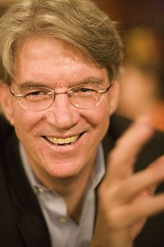
The two political groups that have the most energy, vitality, and interest both nationally and in South Carolina today are the Tea Party and the much newer Occupy Wall Street.
Quick quiz: Which of these two groups could generally be characterized as:
- believing government is broken and politics is corrupt
- a populist grass roots movement
- convinced that special interest groups control the politicians, not the people
- opposing big banks that got bail outs and believing the average citizen was stuck with the bill
- making the major political parties nervous, as the parties don’t know what to do – run from them or embrace them
- using the Internet and new technology to communicate with their supporters and suspicious of the mainstream media
- believing the tax system is unfair and that the average citizens pay too much while the special interests pay to little
- creating suspicions among their opponents that they are just a front group for rich and powerful special interests that manipulate them behind the scenes
- having a fringe element, often decked out in funny costumes, that the rest of the group is a little embarrassed about and that the media tends to focus on.
The answer is obvious – it’s both.
Though both groups resist the idea that they are somehow alike – though on different ends of the ideological spectrum – in reality there is a lot they share in common.
The traditional politicians and the mainstream media are stuck in the old political paradigm of trying to place everyone and everything on a simplistic left vs right ideological political spectrum. They are missing that something fundamentally different is happening.
Bob Dylan said it best: Something is happening here, but you don’t know what it is, do you, Mr. Jones? (or Ms. Haley? or Mr. Boehner? Or Ms. Pelosi?)
Let me suggest a different way to look at this. Instead of this stale horizontal left vs right ideological axis, we should also be thinking in terms of a vertical scale, an up and down axis of change vs status quo. Regardless of ideological difference, both the Tea Party and the Occupy folks would be located high up on this vertical scale of change vs status quo.
Neither group fits easily into the preconceived ideological horizontal left vs right formula and that’s what makes them so hard for the media to understand and why the traditional political elites are so nervous.
Obviously there are lots of differences in these two groups. For one, the Tea Party has been around almost two years and has grown and changed. The Occupy folks just began a couple of months ago – and surely they too will change and morph over time, as well.
So getting beyond all this political science theory mumbo jumbo, what does all this mean in real terms for South Carolina politics?
I believe that if we can think about things in a new way, we can fashion a reform agenda for change that at least most folks in these two groups, and the vast majority of independent thinking South Carolinians, can agree on. For example:
- Open and accountable government that makes all government spending, legislation and votes easily available to the public in real time
- Crack down on high-paid, special-interest lobbyists, or even ban them all together if that’s possible
- Ban all campaign contributions from business, political action committees and unions
- Redistricting reform to eliminate ‘safe seats’ so that incumbent legislators are genuinely held accountable via competitive elections
- Greater citizen involvement in the day-to-day decision making of state government.
Can these two groups come together around such a common agenda for reform in South Carolina? Yes, they could, but it won’t be easy. And don’t look for any of our existing so-called political leaders to lead this charge. Most are stuck way too far down the change vs. status quo axis, and way too busy protecting themselves and the special interests they serve.
So, as with any genuine democratic movement – be it the Arab Spring in Cairo or the reform movement here in South Carolina, ‘we the people’ are going to have make it happen.
Regardless of where we begin – with the Tea Party, Occupy or the independent middle – we all need to get involved.
This is one political quiz none of us can afford to fail, because on the most basic level, both groups are right. Our state government is broken. Our politics is corrupt. And only we, the citizens of South Carolina, acting together and with common purpose, can put an end to the venality and clean up the mess.
Phil Noble is a businessman from Charleston, and he currently serves as President of the South Carolina New Democrats, an independent reform group started by former Gov. Richard Riley. Contact Mr. Noble at www.SCNewDemocrats.org or phil@scnewdemocrats.org.
DISCLAIMER: The opinions, beliefs, and viewpoints expressed by the author are those of the author and do not necessarily reflect those of CRESCENT: The Magazine.
Tweet

Comments
10-26-2011 « Markbrian's Blog
[...] You can keep your head buried in the sand and beleive everything the main stream media tells you OR you can wake the freak up America! Please read another great article about the Tea Party and the Occupy Wall Street Movement [...]
Mark Brian
Absolutely true and brilliant!

WHAT'S GOING ON: Myrtle Beach to Host January Presidential Debate
Published Date : October 21, 2011
Author : admin

South Carolina Republican Party officials announced this morning that Myrtle Beach will be the site of a “First in the South” GOP presidential debate on January 16, 2012.
Fox News Channel will broadcast the debate that comes just five days before the state conducts its Republican Presidential Preference Primary.
More details will be made available at a Tuesday news conference in Myrtle Beach.
Tweet

Comments

WHAT’S GOING ON: Honeywell Announces $25 Million Expansion in Greenville County
Published Date : October 17, 2011
Author : admin

Honeywell International today announced that the company will expand its current operations in Greenville County.
“We are pleased to move forward with plans to expand our facility in Greenville County. The Greer facility is an important part of our overall operations and this expansion will help it remain competitive. South Carolina has provided us with an excellent business climate and the skilled talent we require,” Honeywell site manager Ray Kime said.
“It’s a great day in South Carolina when another world-class company like Honeywell International decides to increase its footprint here and create 30 new well-paying jobs. Announcements like this show we’re doing the right things to promote economic development,” said Governor Nikki Haley.
The expansion is expected to be complete in 2016 and is slated to create an additional 30 jobs at the site.
According to SC Department of Commerce Secretary Bobby Hitt, “Today’s announcement builds on our reputation as a player in the aerospace club. South Carolina’s business-friendly environment and talented workforce continue to help our existing businesses, like Honeywell, find success.”
The facility handles more than 400 engines/modules each year, performing more than 40,000 piece part and systems component restorations annually.
Honeywell first established manufacturing operations in Greer in 1982, and opened the repair and overhaul facility in 1988.

Tweet

Comments

CRESCENT Places: Grits & Groceries (Part 3)
Published Date : October 17, 2011
Author : admin
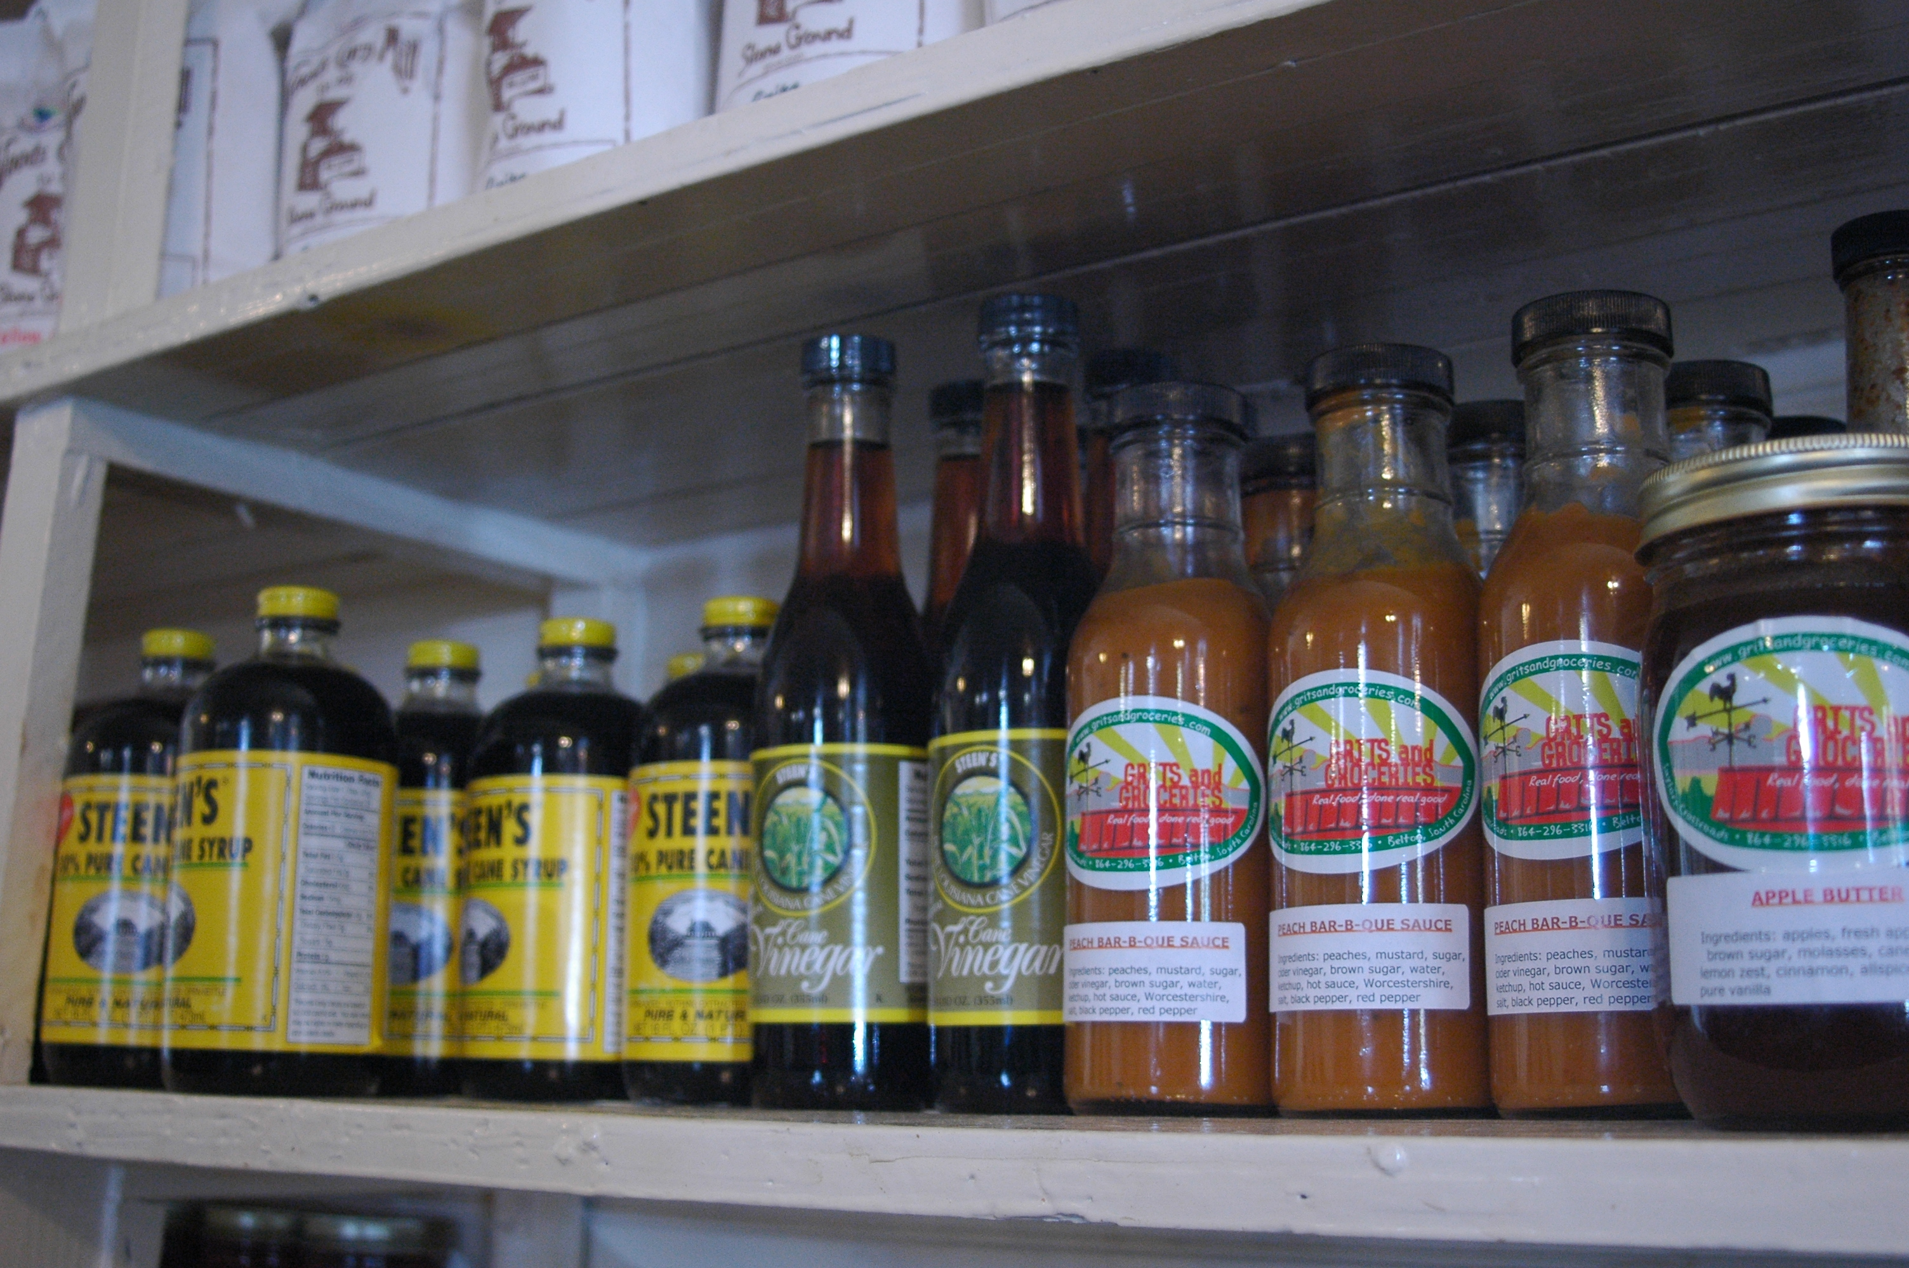
CHARLESTON LOSING JOHNSON & WALES UNIVERSITY
HEIDI: Shame on them for losing that.
When I was in school in Charleston, I think the restaurants were great because they had a great source of qualified, cheap labor with all the students at Johnson and Wales. Because we worked for $25 per day shift pay. You’d work for noon to midnight. You wanted to be there. I think what’s happened is they lost that work force, but Charleston has rebuilt itself as the hottest food area right now thanks to… Thanks to Sean Brock for getting the name out.
JOE: The last 3 James Beard Award winners (Best Chef in the Southeast) have come from Charleston with Sean Brock, the guy that owns FIG (Mike Lata), and the guy from Hominy Grill (Robert Stehling). Basically, that’s the last 3.
HEIDI: Obviously, they’ve rebuilt their work force. Our biggest problem between here and New Orleans is that, in New Orleans, there are so many independent restaurants and they’re good. Here, there are so few independent restaurants. We’re competing with chains and that’s really hard for us because they have the buy-in-bulk power to buy food and keep it at a price that we don’t. So maybe 2 years ago when the prices really got outrageous, our supplier went up 30% on everything. We said, “OK, we’re going to stop buying and only buy local.” Local is 80% of what we buy. It comes within a 100 mile radius of us. We try to buy everything we can from South Carolina first and then we work to the closest state to us to keep as much money in our tax zone as possible. I mean, I need a BMW because it is made in South Carolina. I would love a BWM SUV (Editor’s Note: So would we.). We have about a dozen farmers who grow for us. It took a while for us to convince them we would buy enough for them to grow. They kept showing up with 4 tomatoes or 5 pounds of okra. We use 60 pounds of tomatoes a day. We’re serving from 350-400 people on Saturday. We’re serving 1000 people a week.
BEING ABLE TO BUY LOCAL
HEIDI: We got shrimp from Saudi Arabia one day. Can you imagine that? Shrimp from Saudi Arabia? We don’t use them, but our salesman was trying to sell us shrimp from Saudi Arabia and I was like, “What? Why can’t we have South Carolina shrimp?”
He told us it’s cheaper. And evidently, we (the United States) paid to build the aqua-culture beds there. They’re raising shrimp in the desert with government dollars. That’s my understanding. I haven’t researched that. It’s my understanding, “We’re sorry we bombed you. We’re going to give you an industry, and we’ll buy from you.”
Our menu changes every day, so that gives us the flexibility to work with who’s growing what. Come December, January, February, we have to get very creative with who’s growing what so that we can have local food. It will grow here all year but it is such a small market, we don’t have enough people growing for us. So this year, I’ve committed to 2 small farmers to buy everything they produce through the winter.
I may be giving it away, I may be cooking it, but I’ll buy it so they’ll grow it for me. It’ll be greens, Swiss chard, green-house tomatoes.
We have a guy that grows green-house lettuce and tomatoes. I don’t know what he did before, but he did something very technical before he started this hydroponic lettuce and tomatoes. It’s fabulous and wonderful. It grows in a pod. He has zero waste with it. Everything left over goes to his livestock. He makes this perfect mix of natural fertilizer, I guess is the word, the natural fertilizer tea the lettuce grows it. It’s sweet, it’s perfect and it’s local. He brings it to us 3 days a week when we’re using a lot and 2 days a week in the winter when we’re not using as much.
THE LOCAL AGRICULTURAL COMMUNITY RESPONDS
HEIDI: We had a really hard time, maybe 3 years, of convincing people to grow enough food for us in enough variety. We could get tomatoes, peppers, cabbage and greens, but we have someone growing asparagus and broccoli and Swiss chard. We needed someone to grow more variety for us so for the first 3 years we worked on that. Made a network of people. To know a network of people and actually ask them to plant different plants for us. They were “Oh, wow, people are interested in this. I can sell it.” We just had to introduce them to it. I think it is funny. People think we cook really far out food, but it’s not. We’ve just gotten used to Main Street food — beans, broccoli, spinach, and zucchini. That’s all you see in a restaurant because it is cheap, it lasts a long time, and it grows in Guatemala, so we can get it cheap.
So to get people to grow Jerusalem artichokes… I love Jerusalem artichokes. Nobody knows about them any more. When I was a kid, Jerusalem artichokes grew everywhere. They were peasant food. You pull them up and you can do anything with them you can do with a potato. We made a pickle with them. My granddaddy’s pickle.
WHAT CAN BE DONE WITH SOUTHERN FOOD
HEIDI: It’s just like a purlow, you can put anything in a purlow. Same thing in New Orleans in jambalayas and gumbos. Anything can go in there and make a meal. We’d put out Sunday dinner for friends sometimes and we might have 20 people show up, we might have 200, just depends on how big the pot of rice is. Need more food, make more rice. We’re good to go.
SATURDAY NIGHTS AT SAYLORS
HEIDI: Since there are so many chain restaurants, we try not to eat in a chain restaurant. Sometimes we were wishing we had food from New Orleans or food just the way we want it, so we decided we would just open up on one Saturday night a month. We would sell 100 tickets to it and we would cook whatever we wanted. It’s always a different theme. It’s exactly what we want. May not be what the market wants, not the most trendy food. September we used the “Charleston Receipts” cookbook and recipes that I’ve always loved out of it. We’re doing a meal out of it. We’re trying to do 12 different dishes and the idea is it is not where you just come in, sit down, eat and leave. It is 3 hours. We have music. We put food inside, we put it outside. You have to sit with people you don’t know.
It’s like our own little mini-festival once a month. October is “Cowboy Steak” night. We have a local beef grower that we’ll buy. The last time, we bought a half a cow and had to cut it in quarters. We cooked it on our smoker outside. Just sliced big slabs off of it.
WHERE THEY GO WHEN THEY’RE NOT COOKING
For me, it is sushi. I go to Greenville and eat at Tsunami. That’s what I really want. And the other thing is from New Orleans. We miss the eclectic soul food. We miss the mom-and-pops that aren’t American food. Middle Eastern, Vietnamese, Thai restaurants, so we like to go to the Middle Eastern restaurant in Greenville, the Pita House, we’ll stop in there. It’s really good. The food is really fresh and nice. Here, we have a Mexican restaurant, but it’s not super authentic, but they are our only neighborhood restaurant that buys food and cooks from scratch. Called El Titanic. Yeah, the true guilty pleasure. What’s that good ice cream shop?
JOE: Danny Bell’s
HEIDI: Danny Bell’s. (Looking at Joe, she asks) Is that your guilty pleasure or just pleasure? There’s a place in Honea Path that has no sign that backs up to this taxidermist. There is a sign that says “Either way, you get your goat back.” He has hamburgers, grilled chicken. That’s it. He has a hot dog, but he gets fresh ground meat every day. He has 12 seats and they’re closer than this (motioning to her own dining seats) and they have the best…it’s fresh ground beef. He picks it up from somewhere everyday. When you order, he takes a big handful of beef, slaps it on this grill that he’s been cooking on for 30 years, so it’s well-seasoned. Good hamburger bun. He steams them and warms them up. Good condiments. All year long, he has the most beautiful tomatoes. He’s got a contract with God to get those from somewhere. Perfect hamburger.
Stay Tuned for Part 4 Next Week. Read Part 1 HERE. and Part 2 HERE.

Tweet

Comments

CRESCENT People: Tucker Eskew (Part 3)
Published Date : October 17, 2011
Author : admin
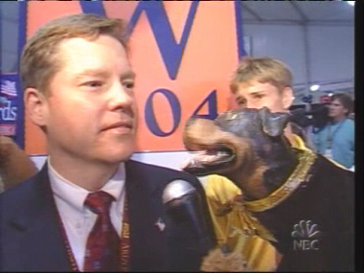
DURING THE WAR
It was the early days of the war in Afghanistan, fast forwarding now a month or two after 9/11. America was getting attacked heavily by our opponents, terrorists, radical jihadists, and their allies in the global media. A lot of this was happening in the region, and some of it was happening in, what was then, a world media center including the Arab and Muslim press, in London. I drew the short straw and went to London instead of Islamabad, but I took my wife and the then one child and lived in London close to six months and worked with a great leader in Tony Blair.
I got to witness a media culture there which sadly I feel is kind of drifting west. It was, without a doubt, the most corrosive cynical media climate that I’d ever been exposed to. Here I was, the son of a journalist who’d been through some very tough battles, including with reporters and their bosses, and yet we could retain the fairness of the American public debate. This was a culture where newspapers would put illustrations of George Bush with blood dripping off his hands on the front page or our vice president with fangs that dripped blood and painted as a warlord. These were papers who sold copies in the millions. It was a very (news)paper-driven culture, and I think it is to this day, as opposed to the television which is the driving force in political campaigns here.
I remember the first day I got there, I told people that the way I operated was, I just like to immerse myself in the press. I want to read everything I can. I want to see how it’s playing on TV. I want to live it and breathe it. The day before I went home, they threw a little luncheon for me, and I told them immersed myself like I said, but that I just wanted to go home and take a bath. It was that ugly a climate, and yet, Tony Blair is a model for our current president after this election the change in parties from the left back toward the center.
Where are we now? We’ve lost confidence. We’ve “lost trust,” to borrow a phrase from South Carolina. We’ve lost trust in the institutions all up and down the line.
Gallup did one of its periodic surveys of how the public views various institutions. You’ll find the military as the most trusted institution in our society, and you’ll see our Congress ranked at the very very bottom. The media takes it on the chin pretty tough, and it’s dropping – dropping a little faster than other institutions.
That center, that civic space that holds everything together, is crumbling. I think it’s incumbent on all of us to look for ways, small ways in our daily lives, to try to keep that center, regardless of ideology, that we keep that civic space where we work to get things done for the country.
Stay Tuned for the Final Part of the Feature Next Week. Read Part 1 HERE and Part 2 HERE.
Tweet

Comments

WHAT’S GOING ON: What Does Autumn Mean? Ask the Garrisons
Published Date : October 17, 2011
Author : admin
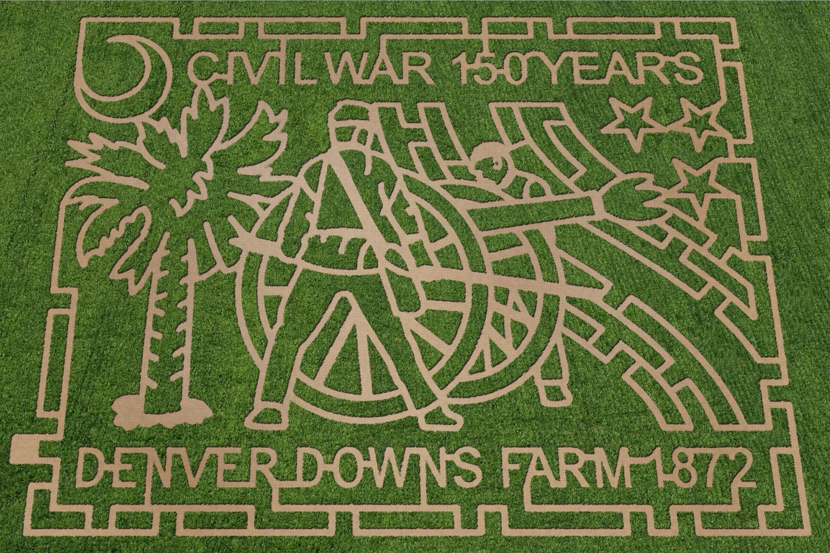
It’s like a grade school writing project. “What does autumn mean to you?”
Easy.
Falling temperatures. Changing colors. A giant maze made of corn.
A giant maze made of corn? Yep. A giant maze made of corn.
On Highway 76 outside Anderson, just off Interstate 85 Exit 19, the Garrison family opens its 900 acre farm to the public for an annual fall celebration.
Denver Downs Farm’s corn maze and pumpkin patch is open Friday through Sunday through October 31 with activities that include a giant pumpkin patch, hay rides, a corn cannon, farm football, zip lining, bonfires, music and more.
This year’s festival commemorates the 150th anniversary of the War Between the States and includes a 12 acre corn maze as the event’s centerpiece. After finding their way out, visitors explore a variety of games and activities like a cow train, duck races, corn ball volley, a giant slide, corn hole, and horse shoes.
Admission to the annual Corn Maze & Giant Pumpkin Patch is $10 per person. Children 24 months and under get in free. Hours are Fridays from 5:00 p.m. until 10:00 p.m., Saturdays from 10:00 a.m. until 10:00 p.m., and Sundays from 1:00 p.m. until 6:00 p.m.
The Garrison family has owned and operated Denver Downs Farm since 1872.
For more information and a complete list of activities, visit www.DenverDownsFarm.com.
Tweet

Comments
Jami Mullikin
Cool, I will have to check that out! Fall is our family's favorite time of year. We love taking the day and quick drive up to Flat Rock for apple picking and pizza, it has become our official Fall celebration each year. We went last weekend to Flat Bakery, sat outside and enjoyed cool air and great pizza. If you haven't discovery it yet, I wrote a post about it last week. http://www.pizzatopians.com/three-great-pizzas-from-flatrock-village-bakery-near-hendersonville-nc/ Thanks for the post!

FROM THE DESK OF: Support the Primary
Published Date : October 17, 2011
Author : admin

There’s been a lot of talk recently about South Carolina and its “First in the South” Republican presidential preference primary.
Several local governments in the state have taken a “sky is falling” approach and decreed that their counties will not participate in January’s primary election because they aren’t going to foot the bill with taxpayer money.
On the one hand, bravo! At first blush, that’s a fiscally responsible decision, but when you dig just a little deeper, there’s so much more to the story that hasn’t been considered.
First, South Carolina is a “carve out” state. It has a special place on the Republican primary calendar because we 1) reflect the views of a large segment of the national voting population and 2) the sizes and costs of our media markets are affordable enough to create a playing field open to more candidates.
What does that have to do with anything?
Think about it. With several South Carolina counties, LARGE South Carolina counties, openly appearing to opt-out of the primary process or challenging the process in court over the past couple of weeks, presidential campaigns have been a little nervous to come here, and understandably so.
Sure, we have the “First in the South” primary, but top-tier candidates aren’t looking at that fact and saying, “The most effective use of my time, resources, and media dollars is in a state where the biggest counties won’t participate in the primary.”
They’re allocating time and resources elsewhere. That means they’re spending less money to hire state-based staff, rent office space, lure people to town hall meetings at restaurants in towns you’d have to be from South Carolina to have heard of, run media tours that showcase the state, and, well, you get the idea.
Second, there are some who say that the primary doesn’t matter, that it’s not a real election. Really? That’s ridiculous. It’s a very real election. After all, how do delegates cast their votes at the Republican National Convention?
For South Carolina, a winner-take-all primary state, the top vote getter in the January primary gets the votes of the state’s convention delegates. If our counties thumb their noses at the primary process, those county governments will consciously disenfranchise large influential voting blocks and may skew vote totals for a candidate who might not otherwise win – giving our state’s votes to someone who might not be the state’s real choice.
In the state with the “First in the South” primary, a gateway to the rest of the nation, and has a history of picking the eventual GOP nominee, there’s a lot at stake — both politically and economically.
The state Republican Party has said repeatedly that the costs will be covered. Local governments need to cool their jets or at the very least have frank discussions with South Carolina Republican Party leadership about the true cost, funding, and operation of the January 2012 primary. Not doing so and passing ordinances or filing law suits off of knee-jerk reactions is costing the state more than those folks realize.
Tweet

Comments
Counties challenge First in the South GOP primary – S.C. Politics « Iron Mill News Service
[...] FROM THE DESK OF: Support the Primary : CRESCENT — South Carolina Life, Politics & A Little Bi.... 34.147031 -80.907725 LD_AddCustomAttr("AdOpt", "1"); LD_AddCustomAttr("Origin", "other"); [...]
SCGOP Press Clips, 10.19.11
[...] Why the primary matters [...]
Spartanburg Tea Party » Four counties threaten our revelance in presidential primary
[...] Crescent Magazine has their own viewpoint: Several local governments in the state have taken a “sky is falling” approach and decreed that their counties will not participate in January’s primary election because they aren’t going to foot the bill with taxpayer money. [...]

CRESCENT Things: James Beard Award Winner Ted Lee (Part 3)
Published Date : October 17, 2011
Author : admin
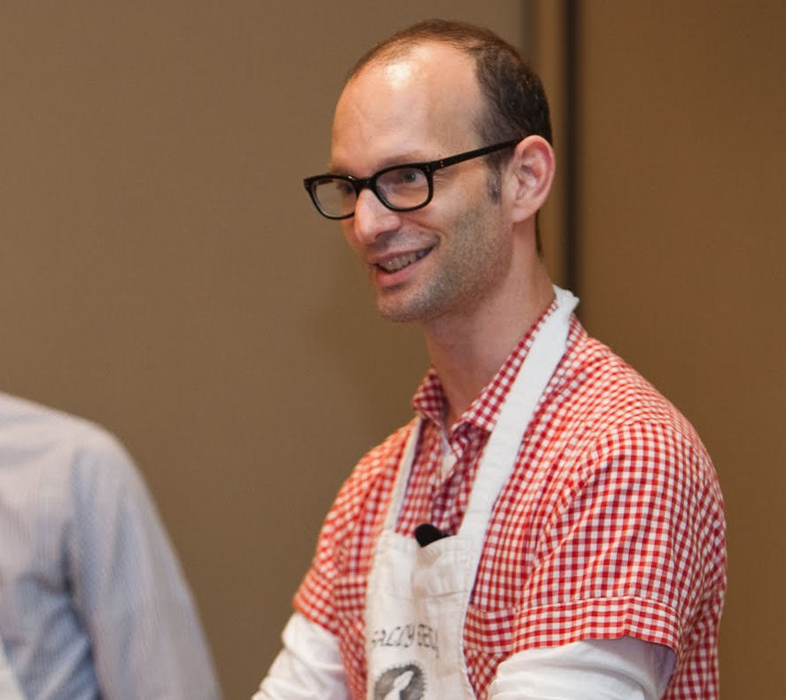
SHARING CULTURE
You learn a lot by serving people your food and seeing responses. I served Huguenot Torte which is like a classic Charleston dessert. Really easy like egg whites, apples and sugar. Bake it and I served this food editor who was the food editor for the New York Times Magazine. I have never seen her eat like she at that Huguenot Torte. She was like scraping her plate, she could not get enough of the stuff. And it’s like, cool. That’s like, we love Huguenot Torte and all, but to see what connects. And she ended up writing a story or having one of her writers write a story getting into the history of it. It’s something that’s made a lot in Charleston in the tea rooms. You know, there are all these tea rooms that have opened in Charleston in the church parish halls and they serve old school, South of Broad family recipes. There is so much to discover.
ANOTHER GREAT THING ABOUT SOUTHERN FOOD
Another great thing about Southern food is it’ll never be dated. There is always something you haven’t heard about. Somebody who is doing amazing work. I don’t think I’d really reacted as deeply with South Carolina strawberry growing history as I did this year. I just happened to be introduced to some strawberry growers. It’s such an early crop, and it’s such a great group. And it’s been known since the 1800s. There is this really cool guy who used to write about it, David Shields at the University of South Carolina. He’s a professor of American Studies and he’s doing a lot of research into what was grown in the South Carolina like the history of growing in South Carolina. With a special focus on the time when farmers were experimenting because they had just come over from wherever they came from and didn’t know what would grow in South Carolina.
Very trial and error, experimental, innovative. What he does is study the letters farmers were writing to each other like saying “This is what I was growing here and was all right. This didn’t grow so well.” He can really geek out on what was grown in South Carolina. There’s not anyone who does as much as he does on history on agriculture in South Carolina. The changes that are happening now in farming.
There’s a farmer who’s a fourth generation who turned all his field organic 6 years ago. He’s completely diversified. He was growing mostly tomatoes. Johns Island in the 80s, everyone was trying to get the fast food tomato dollar, but that bottomed out. In the 50s, it was the potato and everyone started growing potatoes and the market bottomed out. The great thing about food culture, it is always changing.
EXPECTING BETTER FROM WHAT WE EAT
It doesn’t change over night. It takes education. People sort of reorient themselves and that’s why, you know, it just takes a lot until you realize you’re not going to be able to buy South Carolina produce every day of the week or every time of year, but if you know the produce is South Carolina grown, it sort of psyches you up, you get into it. This asparagus came in, the grapefruit came in, there is all this citrus. Grapefruit was just going out, asparagus was just coming in. You can tap into that rhythm. I’m always thinking from a home cook’s perspective because that’s what I do. The more you’re excited to cook, the more you’re going to do it because you can create every reason in the world to not cook.
CHANGING FOOD CULTURE ACROSS THE STATE
There’s this great chef, Charlotte Jenkins at Gullah Cuisine. She grew up 6 miles north of Charleston in a Mount Pleasant community called Six Mile. Her husband grew up on Yonges Island which is like 12 miles south of Charleston. She wrote a cookbook, and her husband was talking about some of his food traditions on Yonges Island. She was talking about some of hers, and it was clear they were a little bit different and I talked to her daughter in Greenville at a book festival and I said, “It was so interesting to see the differences in where your mom grew up and where your dad’s parents lived.” “Oh, my God, my dad’s family, they were some country people. I’m telling you, we don’t cook like them.” It was really interesting. Here are two elements of African-American culture who grew up 18 miles apart and yet it’s like, “No, we don’t cook like them.” Just small little differences. He was using seaweed for seasoning. He told us about using seaweed to season a pot of shrimp when he was growing up. To his daughter, this was just so country.
It’s just discovering how differently people cook from place to place. People are always telling us “Oh, not another Southern cookbook.” It’s like, “There are as many Southern cookbooks as there are Southern cooks.”
And I don’t mean just home cooks. Some of the best treasures I see are family cookbooks. Family recipes that have been handed down. Who knows where they came from?
Stay Tuned for the Final Part Next Week. Read Part 1 HERE and Part 2 HERE.

Tweet

Comments

WHAT’S GOING ON: SC Receives "Preclearance" from US DOJ for New SC House District Lines
Published Date : October 12, 2011
Author : admin
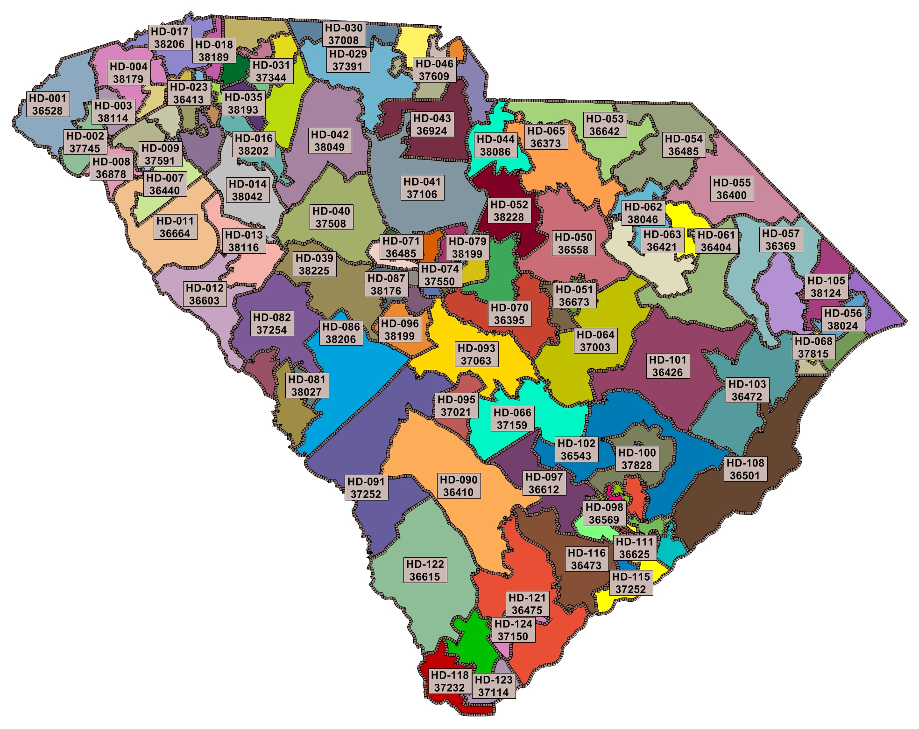
Yesterday, the US Department of Justice approved the General Assembly’s submission for newly redrawn state House districts.
While the approval was given in under sixty days, insiders expect a number of lawsuits to be filed in opposition to the new lines.
State lawmakers took to their social media accounts last night to applaud the approval. According to Speaker Harrell’s Twitter account, “DOJ informed us today they have given preclearance to House Redistricting Map. Congrats to everybody who worked so hard on this plan!”
Because South Carolina remains subject to the Voting Rights Act, the Department of Justice must provide “preclearance” when district lines are redrawn following a census count. DOJ still must provide approval the state’s other electoral districts.
Tweet

Comments

FROM THE DESK OF: There's Plenty of Blame to Go Around at USC. BY: Taft Matney
Published Date : October 12, 2011
Author : admin

As the walk-away music from “The Incredible Hulk” plays in the background, Stephen Garcia ambles slowly down the road, his outstretched thumb hoping for a sympathetic passer-by to give him a lift back home to Florida. “So long, Columbia,” his body language says in a dejected whisper.
You know, it’s easy to bash Garcia. He’s a kid who had more chances than reasonably expected, and he blew every one of them with explosions so bright, they looked like a 4th of July fireworks display.
Go big or go home. Right?
Well, now he’s done both, but is it really fair to cast all of the blame on him?
Think about it. He blew EVERY chance he got, but there were people giving him those chances. Suspensions were meaningless because by the time a suspension was imposed, it was lifted under the auspices of, “Stephen’s learned his lesson.”
No. The real reason those suspensions were lifted was that Carolina’s athletic officials felt Garcia had more to contribute. He was, no matter what his off-field conduct indicated, an asset. Yeah. He was a distraction, but his skills were needed, and that need overshadowed his behavior.
After all, over his career with the Gamecocks, Garcia:
- Led USC to its first SEC East Division title
- Had 47 touchdowns
- Became the third quarterback in school history to throw for more than 7,500 yards in a career
- Sits third at USC for all-time pass attempts, completions, and passing touchdowns
- Has the third most starts in school history at 34 (Todd Ellis had 43, and Steve Taneyhill had 40).
It was only after #5 didn’t have anything else to give that his misgivings became too much for the Gamecock athletic program to handle.
At least they waited for him to bury his grandfather before they booted him off the team.
Look, I’m not defending Garcia. His alleged love of excess cost him dearly. Many of his decisions were, in no other terms, just stupid. What about athletic director Eric Hyman or the Head Ball Coach Steve Spurrier, though? Should they share any blame? Any at all?
It’s not their jobs to keep Garcia acting like a choir boy. That’s HIS job. That’s HIS personal responsibility, but if Hyman and Spurrier REALLY cared about this kid as much as they chest pounded in the media, wouldn’t they have tried to get him some help? At the very least, if he refused the help, shouldn’t they have kicked him off the squad THEN? After all, by most media accounts, he has a problem that’s only going to get worse without treatment.
Instead they waited until Garcia’s eligibility was almost up. There was no more gas left in the tank. That’s the point they chose to cut ties – when HE was no longer in a position to help THEM.
Like I said, I’m not saying Garcia’s actions should be defended, but at the same time, Hyman and Spurrier have been in a position for years to offer the kid some help and fix a problem with their football program.
I can’t stand disingenuous sentiment, the USC athletic department seems to have it coming out the wazoo.
Here’s hoping Garcia can eventually pull it together.
Taft Matney is the editor of CRESCENT: The Magazine.
Tweet

Comments

WHAT’S GOING ON: Boiling Springs Fire District Dedicates New Station. Already Saving Lives
Published Date : October 10, 2011
Author : admin
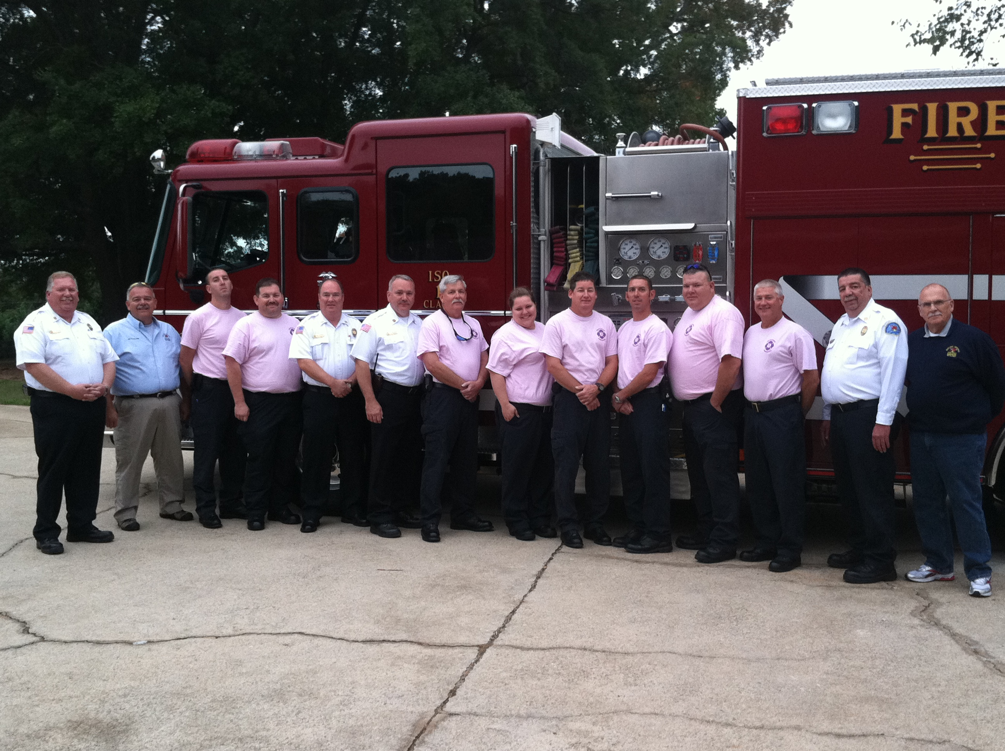
This morning at 8:00 a.m., only days removed from a hairline Greenville County Council vote, the Boiling Springs Fire District dedicated the property at 208 Blacks Drive in Greenville County as its newest fire station.
The debate over the station began in May of this year when county council voted against the district’s request for a 0.7 mil adjustment in its revenue stream. Chief Steve Graham, then presenting the district’s most recent survey from the Insurance Services Office (ISO) to council’s Committee of the Whole, told council members that district representatives would soon be back and seeking council support for a general obligation bond to construct two new stations as required by the ISO report.
ISO was invited to address County Council, but because the meeting could not be closed, and media not excluded, representatives were prohibited from speaking.
The fire department rating report ISO provides to insurance companies is one of the major factors used in setting premiums on commercial and residential property. Using a classification system ranging from 1 (superior fire protection) to 10 (not meeting minimum requirements), Boiling Springs’ current ranking is a Class 1 — one of only 44 departments nationwide to carry that rating. Without meeting ISO’s requirements, Boiling Springs would have seen its rating drop to a Class 3, which would have increased premiums as much as $30 per year on each $100,000 of assessed value.
Boiling Springs Fire District officials began searching for two properties with locations acceptable to meet ISO’s requirements when they located a former church in the process of relocating. The site of the former Vineyard Church was, according to ISO, suitable enough in location that if the district could locate there, it would eliminate the need for the second station.
Working with several members of county council, BSFD officials began courting support for a $2 million general obligation bond that would pay for the purchase of the Vineyard Church property, renovation of the existing structure to convert it in to a fire station, and purchase of the equipment for the station. District officials said this was preferable to requesting a $5-$6 million bond to purchase two sites and develop them from the ground up.
After a number of hurdles, last Tuesday night, county council voted its required 2/3 majority to issue the bond. The bond will cost property owners less than $5 per year for each $100,000 of assessed value.
Wednesday morning, Boiling Springs personnel began preparing the site for operation. During the day, they received a call regarding a resident of nearby Rolling Green Circle who was unable to breathe. Responding from the site of the soon-to-be new station, emergency personnel arrived on scene in 47 seconds and had the patient on oxygen and stabilized for EMS crews in just over a minute.
Response from the district’s next closest station on Pelham Road would have been between 3 and 4 minutes, according to officials.
This morning, while Chaplain Gary Rogers offered a blessing over the new station and the firefighters who will call it home, another call came in — this time for an automobile accident — and Engine 8 rolled out of its new base.
Tweet

Comments

FROM THE DESK OF: Thanks for a Great First Week
Published Date : October 10, 2011
Author : admin

Whenever you start something new, at the very least, you’re a little nervous. In full disclosure, launching CRESCENT was no different.
Professionally, a lot of time and effort went in to creating a web-based presence with the right balance of interests — each focusing on South Carolina.
Personally, I wanted people to like what we put together. I wanted people to start seeing a different side of our state. I wanted people to see that we are not, on balance, what we are portrayed to be by some in the national media.
As South Carolinians, we shape policy. We are entrepreneurs. We entertain. We influence. We have a lot to be proud of, and the feedback we received last week overwhelmingly said that’s what you want to see, and that’s what we want to continue to give.
We constantly need your input, though. To continually evolve, we need you to tell us what we’re missing. What other stories do we need to tell? Drop us a line at input@crescentmag.com and help us improve as we more in to Week 2 and beyond.
Thanks again, and we hope to keep seeing see you here.
Sincerely,
Taft Matney
Tweet

Comments

CRESCENT People: Tucker Eskew (Part 2)
Published Date : October 10, 2011
Author : admin

THE CAMPBELL YEARS
My longest term boss in South Carolina, a great leader in Carroll Campbell, could certainly be measured in intensity. He was an intense campaigner and an intense govern-er – believing in the power of governing conservatism. He was a partisan, and I learned so much from him. I was thinking about Hurricane Hugo which was remembered not too long ago with its anniversary. He had the recruitment of BMW, and Carroll Campbell never took any of that for granted. Not the getting of them. Not the value of them. Not the impact.
It was an incredible thing to watch. Someone at the top of his game who was comfortable talking about business and driven to create opportunity for the people of South Carolina. That was an amazing experience in an era when newspapers were large, well-staffed, and aggressive.
The BMW story started to leak out, and I of course, stood atop the world and said, “Stop!” Well, it did no good whatsoever. The story continued to seep out. We did a good job, I think, of keeping details quiet, but when you started interviewing people who could potentially sell their land to make a BMW happen alongside Greenville-Spartanburg Airport, which was not a foregone conclusion – thank you, Verne Smith — to watch that happen was to see leaks start to get out.
I think I found 150 different ways then to say, “No comment.” The CEO of BMW, whom I’d never met, stepped off an airplane at Greenville-Spartanburg Jetport the night before we were to make this announcement, was introduced to me and said, “You’re the man who says nothing!” What an amazing event by a man driven to make an impact.
I think there was a first draft of history written that day. I jumped out of my skin at that first story. It underplayed the size of the event. It was a very literal story about what had been technically announced as opposed to what the potential was. I looked at that story like, “Gosh! These people don’t understand it’s so much bigger!” It was. It is, and we all know it now, but as a spokesman, as a communicator, my job is to stay on top of the story. What can I say? The AP story was kinda wrong, and I was kinda right to complain about it, and that’s the lives that communicators lead.
After about eight years of Carroll Campbell, I spent time in Columbia with this startup company and was overwhelmed by this force that was rising around us called the Internet. We were a company focused on telephone-based technology, so we were probably doomed pretty early on, but it was a great and amazing learning experience as we learned about the power of the web, sort of hands-on with its rise in business.
THE FIRST ELECTION OF GEORGE W. BUSH
Then I felt like there was one more ride left in me, so I got involved with this fella from Texas and watched history get made here in South Carolina. We took on John McCain and a large field of candidates. After that campaign, columnist Robert Novak, who passed not that long ago, said that was one of the top two or three most intense campaigns he’d ever seen.
We were incredibly successful. It’s a campaign I’m proud of. We won. We won a tough, hard-fought campaign – a fair campaign – and my family picked up stakes and moved my 7 1/2 month pregnant wife to Austin, Texas. Her doctor that we chose on a preliminary trip to Austin had to leave the practice of medicine between choosing her and our arrival, so we had no doctor, but we found one.
So we went through that amazing campaign, and I was the first communicator dispatched out to Florida for the recount. Governor Bush and Karen Hughes said, “Put a team together. We’ll get a plane, and you can drop ‘em wherever you think we need ‘em.” I was thinking, “I wonder what I ought to pack.” The advice was that I’d only need something for two or three days, and of course after about a week my wife packed up a full suitcase and FedEx-ed it out to Palm Beach which was Ground Zero of the early days of that fight. It’s where the “butterfly ballot” happened. It’s where the “bulging chad” and the “pregnant chad” and the “hanging chad” and the “dripping chad” and all that craziness…
I’d just come off the birth of a son who was born that August. This was now November. So standing outside the West Palm Beach County Building and looking in to these big plate glass windows, there they were. Workers, ballot workers, and election workers carefully cradling these little bundles and alongside me were photographers and people staring in. Some were smiling. Some were concerned. It suddenly hit me. I felt like I was looking in on the nursery and thought to myself, “Man. That is one ugly baby.” Democracy was being decided by little chips of paper hanging off the side. I gave so many interviews about “the law” as we were advancing it and as our lawyers were fighting it in court, hundreds of people thought I was a lawyer. Believe me. I’m not, but I’m standing there talking to the world press and suddenly confetti would come drifting through the air and a guy in blue and red tights and a cape and a cap and a big “C” on his shirt would jump off a retaining wall in the middle of the picture as “Chad Man.”
There were a lot of moments of great privilege working at the White House. I mean you’re walking along paths that people like Franklin Delano Roosevelt had trod, and yet overseeing the talk radio office my moment of pride was appearing on The (John Boy and Billy) Big Show. All joking aside the office dealing with all of the domestic press had a lot to do, so on the day they mentioned it to me, I volunteered to the president and Karen and the chief of staff to go to one of the offices we’d set up globally.
Stay Tuned for Part 3 of the Feature Next Week. Read Part 1 HERE.
Tweet

Comments

CRESCENT Things: James Beard Award Winner Ted Lee Talks About SC’s Invasion of NYC (Part 2)
Published Date : October 10, 2011
Author : admin
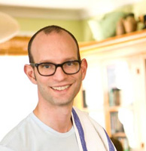
EDITORIAL UPDATE: On the Monday, October 10, 2011 edition of his MSNBC program “Morning Joe,” host Joe Scarborough asked, “What is it about the South? You can’t find a musical form in America, American pop culture, that did not start in the Deep South. Some of the greatest literature, some of, well, THE greatest cooking… What is it about Southern culture that spawned such creativity?” It’s funny you should ask, Joe. Thanks toJames Beard Award Winner Ted Lee, we help answer those questions right here.
While we talked, Ted noted that it really hasn’t been so long ago that you wouldn’t find Southern food in New York, “Not any Southern food that you would write home about,” he added. Thanks to adventurous chefs and a lot of Southern culinary intuition, that’s rapidly changing.
THE NATIONWIDE EXPLOSION OF SOUTHERN COOKING
I’ll definitely give the South credit where credit is due, but nationwide, I think, just the food culture has been focusing, I mean as much as there is that celebrity chef crap that’s going on, it’s becoming a more ingredient-focused nation.
People are asking, “Where does this come from? Where is this grown?” As soon as you do that with the South, it becomes the richest place on earth. It doesn’t take long. If you’re completely ignorant of the South and you’re a foodie, you’ve done the San Francisco thing, you’ve spent time in Napa Valley, you’ve done the whole fresh, seasonal thing and then you go to a place like Charleston and it’s like…there is so much there. My God, crab, shrimp, oysters, tomatoes. All the vegetables, they’re sourcing everything locally and you learn about sorghum and you say “That’s stuff incredible.” You taste it and you say, “I’ve lived in San Francisco all my life and we have everything and we don’t have this?”
Then you taste the different varieties of sorghum, and then you get in country ham.
I don’t think there is any other cuisine in America that rewards inquiry as much as Southern cooking. It’s getting over the sort of hangover of the mid-century which happened everywhere in the US. It didn’t just happen in the South, it happened everywhere. Everything became heavy and sort of casserole-focused and that was an economic thing more than anything.
But the other great thing was so many things endured before industrialization, the traditions, the cane grinding. Like grinding sorghum cane or sugar cane. That’s done is the South still. A family has a cane farm, they have a cane grinding party. That’s something you don’t see everywhere.
I also think that a number of reasons, food and traditions sort of like festivals, the Blessing of the (shrimp) Fleet. Food and life are attached in the South in a way that they’re not in 21st century America. You stroll down to the end of the street, there’s a festival, it’s called Smorgasburg, it’s a food truck festival, it happens every Saturday. That’s a food truck festival. It’s not really about life. The blessing of the shrimp fleet is about life. It’s about the life of the shrimpers and everyone celebrates the start of the shrimp season. It’s a one-time deal and everyone looks forward to it every year. It’s like there’s entertainment, there’s the blessing. It’s a date on the calendar and that’s rare.
SOUTHERN CUISINE REWARDS INVENTIVENESS
So I just think that fundamentally, Southern cuisine rewards inquiry, especially as it has been lampooned for the past 30 years. Somebody tries it though, and says, “Somebody has been telling me the wrong thing. I’m so excited I can pursue this.” Matt and I have seen so many people get excited. And sometimes you’ll have a chef… it’s interesting to see how chefs who are not Southern, what they do with Southern ingredients once they discover them because they go crazier than we do.
David Chang. He was like the first guy in New York who went crazy for country ham. He went crazy for country ham. Southerners know their country ham producers because (to them) that’s the best ham. He (Chang) comes at it from a different perspective, which is less, “I know the best one, I am loyal to this producer.” He’s coming at it from “Oh my God, this is amazing. This one is different, and that’s amazing, too.” He was the first guy to do a tasting plate where you had a Tennessee ham, a Virginia ham, a North Carolina Ham, and a Kentucky ham on the same plate. That’s not really a Southern idea.
I think a lot of restaurants are starting to do it themselves but it’s that thing where you can learn about your own food by someone who is taking it to other places. So it’s interesting to see that perspective, a guy who would put four different country hams on a plate and be like, “See how awesome they are? See how each one has a different flavor?” That’s cool. It’s an interesting sort of …David grew up in Richmond, so he is a Southerner, but you know what I’m saying?
Stay Tuned for Part 3 Next Week. Read Part 1 HERE.
Tweet

Comments

CRESCENT Places: Grits & Groceries (Part 2)
Published Date : October 10, 2011
Author : admin
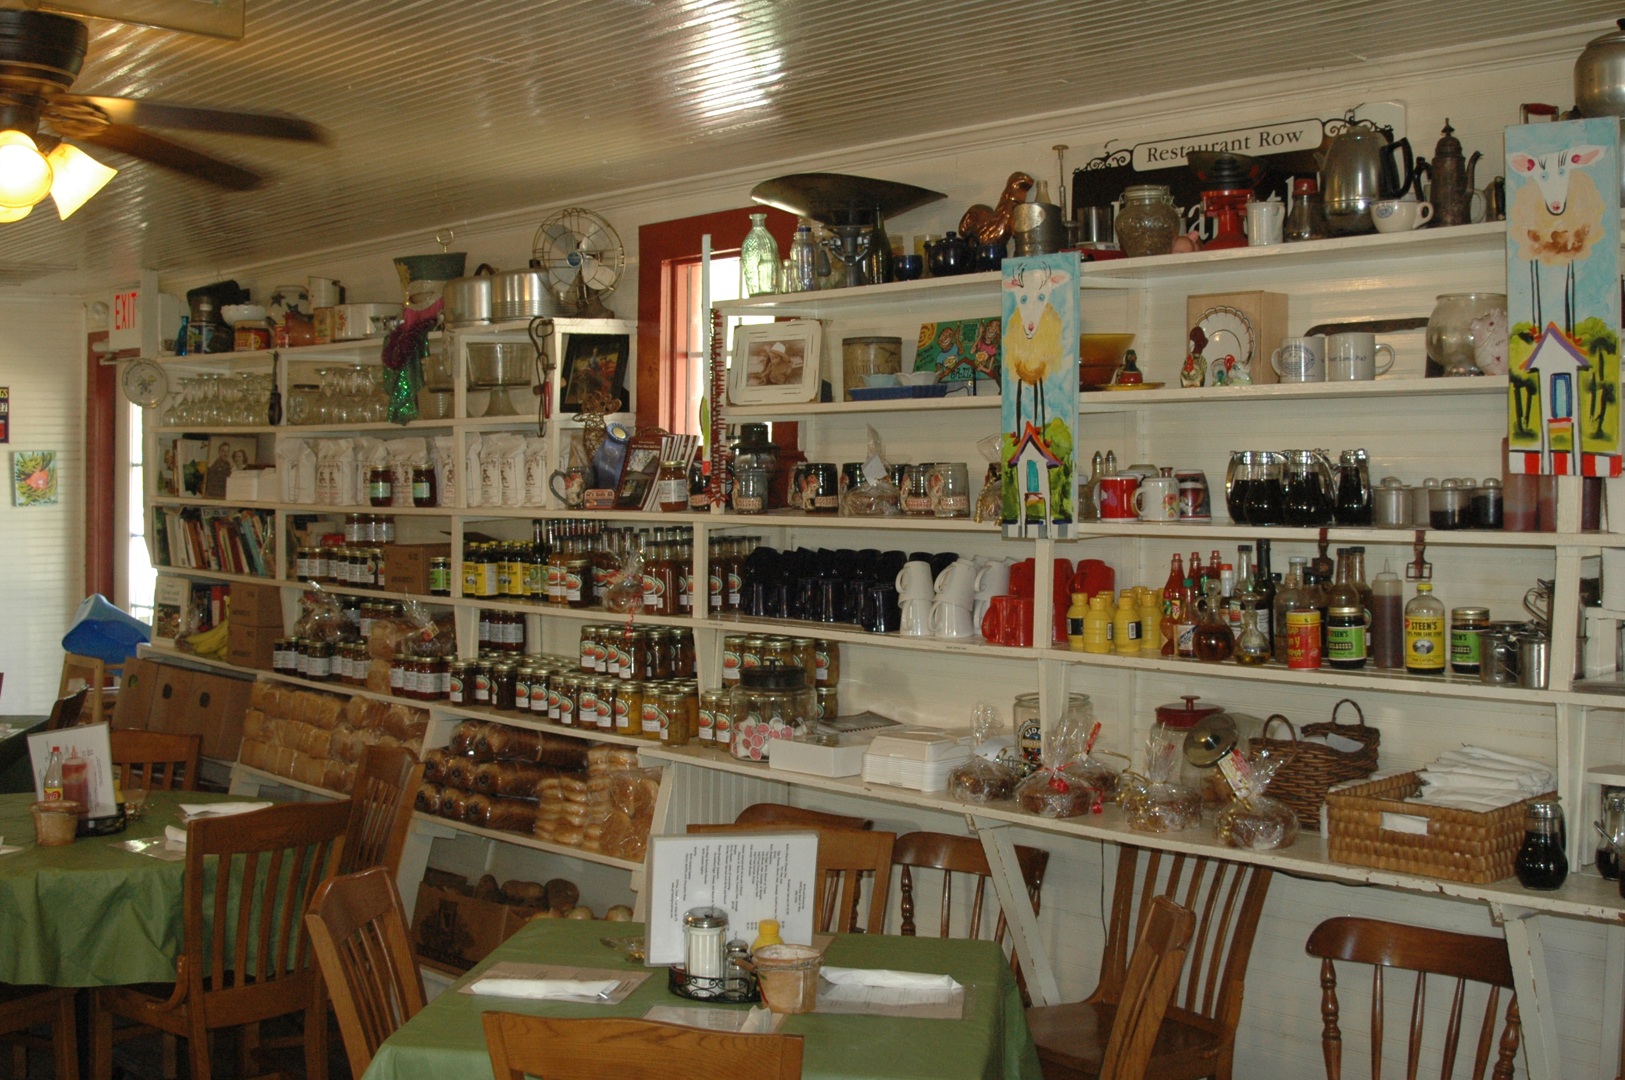
POST-KATRINA NEW ORLEANS
HEIDI: Our house had 9 feet of water in it so we would have lost pretty much our house. And the restaurant in New Orleans survived without much damage except we wouldn’t have had any business for 6 months which would have put us out of business.
JOE: It’s progressing pretty well. There actually more restaurants operating now than there were before Hurricane Katrina. And they all seem to be staying pretty busy. All of the things you go to New Orleans for are there. You know, all the tourist stuff. You get further out into some of the neighborhoods, there is still a lot of work to be done.
HEIDI: The people of New Orleans had a really hard time getting their insurance companies to pay because you had to have homeowners and flood insurance so the flood insurance said we’re not paying, it’s a homeowners problem and the homeowners insurance said we’re not paying because the flood did the damage. So we have friends who have rebuilt their houses and their insurance companies are still in litigation, they’re not paying. We had a friend who basically redid their house with their credit cards thinking their insurance money would come in. But it didn’t for a long time, so they were paying credit card interest on living.
THINK GRITS & GROCERIES ISN’T A DIRECT DRIVE FOR YOU?
HEIDI: That not true. We are actually the center of the universe and everything revolves around us. We have 9 miles to Anderson, 9 miles to Iva, 9 miles to Due West, 45 minutes from Greenville so no matter where you go, we’re in a central location. It’s neat because we can be claimed by everyone. We’re not in Belton, but we’re Belton’s restaurant. We’re not in Honea Path. We’re in the center so we’re everybody’s restaurant. They get to all claim us.
DON’T DEPEND ON GPS TO GET YOU THERE.
HEIDI: Actually, usually the GPSs take you about 20 miles out of the way. They take you to Due West and back.
JOE: We’re kind of halfway between Greenwood and Greenville. At lot of people from Greenwood and Greenville meet here.
HEIDI: We’re the baby drop off point. You see on Saturday and Sundays, all the grandmamas who have had the kids for the weekend are dropping them off and the parents make us like the baby drop off station. They stop at the chicken, take their picture at the chicken, trade off babies, trade off car seats and they’re ready to go their separate ways. It’s pretty funny.
GETTING THE WORD OUT
HEIDI: When we first moved here, we, while we working on the building, we took a booth at the Anderson County Farmers Market so we could introduce ourselves to people. So it built a really nice network…a lot of people got to know us, meet us, interested in us. And Katrina helped because people were interested in the fact that we came from New Orleans and a lot of people think that we came because of Katrina. Several of the newspapers wrote about us being here, Katrina-refugee type stories.
THE BIG REASON TO MOVE TO SOUTH CAROLINA?
HEIDI: We had a baby, at 40, and the only reason we really wanted to leave New Orleans was that school really wasn’t an option there. $10,000 a year for kindergarten. It’s a great place to have a kid, there are tons of great things to do with a kid. I loved the fact it is a pedestrian city. You know all your neighbors. It’s a really close community. But the public schools were not an option for me at all. And the next rung up of Catholic schools and church schools are full, there are no spaces. The next rung up would be like Country Day School and it was 10 grand a year for kindergarten. One of the things we loved about this property, we have one of the number one elementary schools in the state right here, Wright Elementary. They’re kind of left out of a district, it’s a funky little space that kind of got left to itself so the classes are small, the teachers are our neighbors, they know all the kids individually so it was the perfect place for us.
COMPARING SOUTH CAROLINA SCHOOLS
HEIDI: Well, compared to New Orleans schools, you’d notice a huge difference. Schools in Sumter are OK, I would have sent my child to public schools in Sumter, at least through elementary and middle school. Abbeville has nice schools, too. It’s the same thing, they still have parents who show up, that’s the difference. They still a community have parents who are involved with the school where as in the inner city, not so much.
Stay Tuned for Part 3 Next Week. Read Part 1 HERE.
Tweet

Comments

